**TY B.Tech. (CSE) – II [ 2021-22 ]**

**4CS372 : Advanced Database System Lab**

**PRN/ Roll No: 2019BTECS00033**

**Full name: Teknath K jha**

**Batch: T6**

**Assignment No. 12**

**Title: Spatial and Geographic data**

**Objective: To use spatial datatypes like point and trying different CQL queries like for finding the distance between two provided points.**

**Introduction &Theory:**

**Spatial Datatypes like point are used for different methods of Positioning systems for easier execution. They are useful in GIS systems for GPS.**

**Implementation :**

**Creating database of multiple points :**

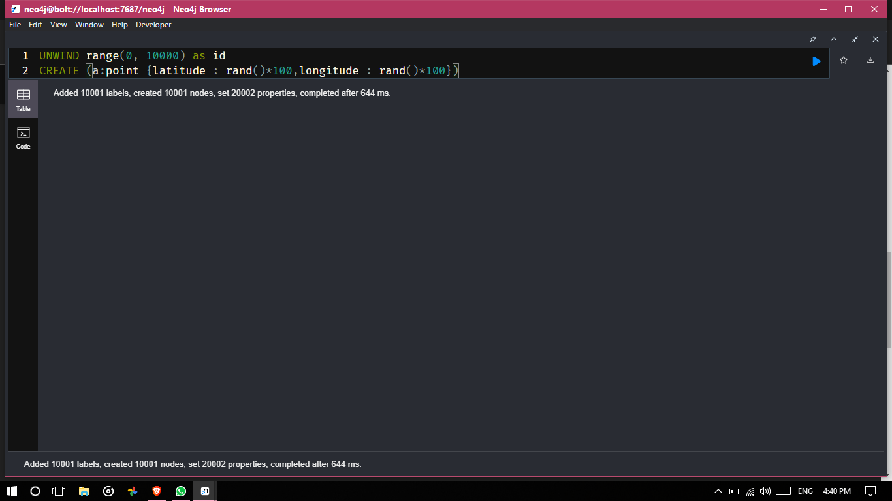

**As given result of the above query : 10001 nodes are added to graph having properties like longitude , latitude , id.**

**Then showing it as graph :**

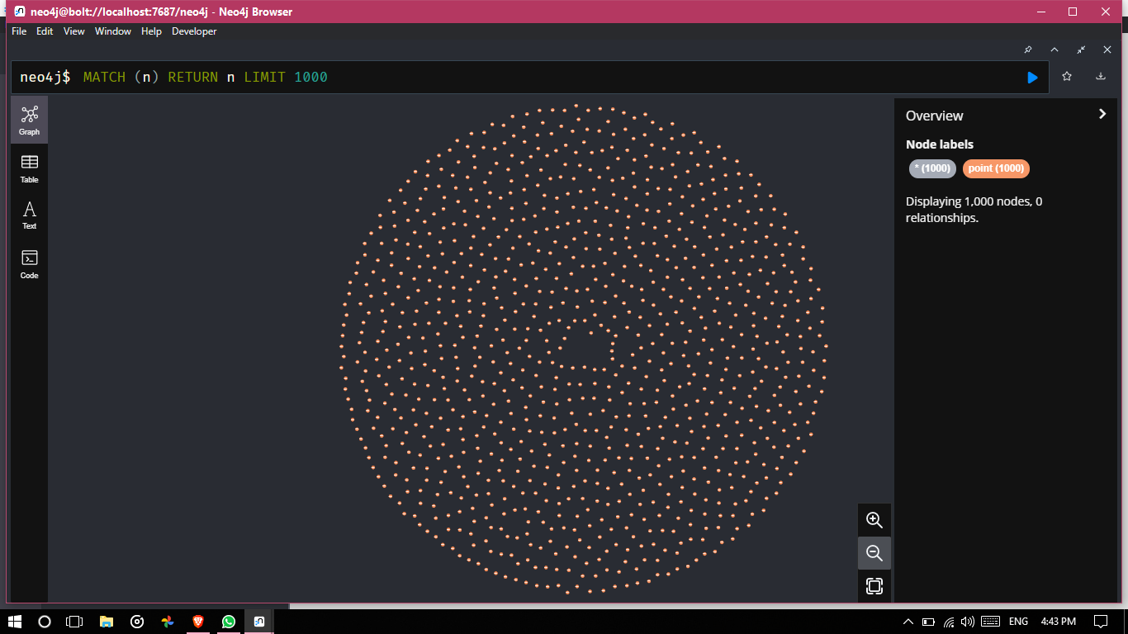

**Then adding relationships between the points :**

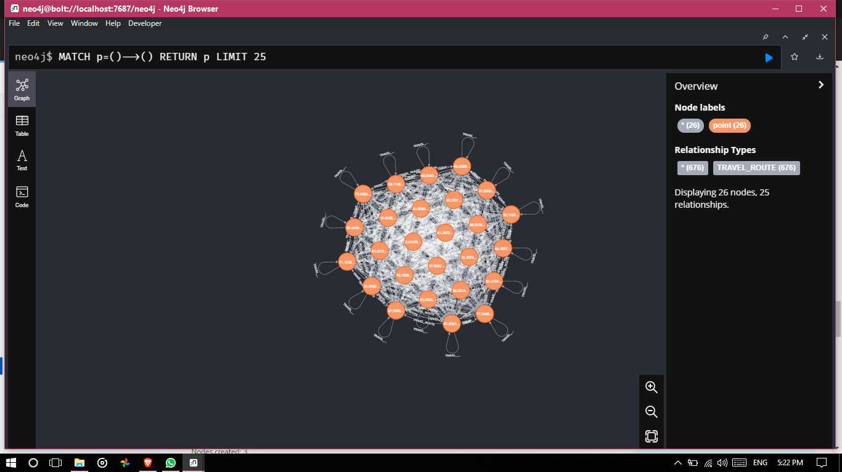

**Showing it on the different scale :**

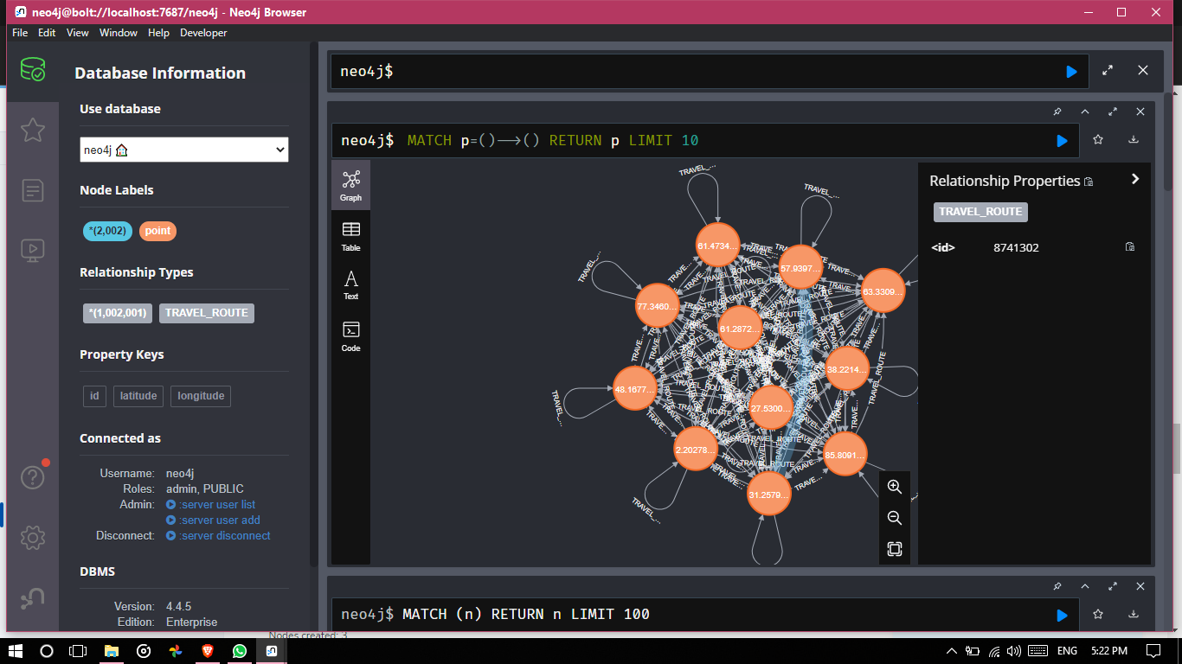

**Practicing different spatial functions :**

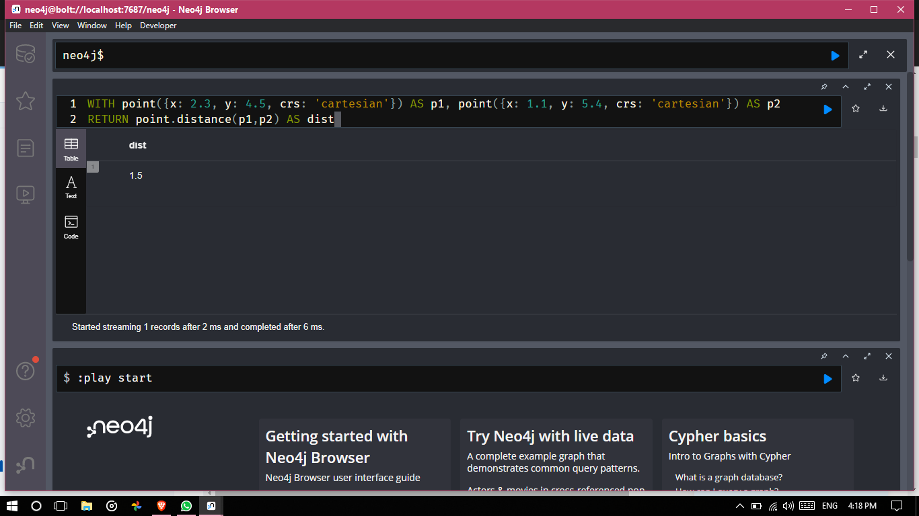

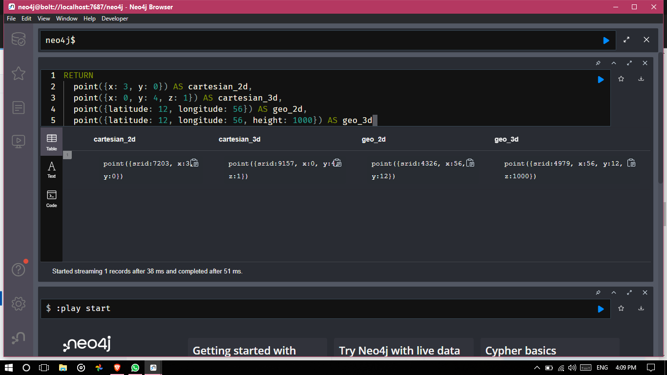

**Conclusion :**

**The spatial datatypes like points makes easy to work in GIS domains rather traditional datatypes.**